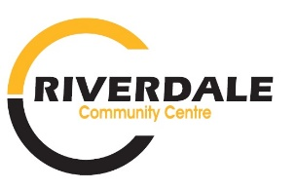
Riverdale Community Centre

2025-2026 COMMUNITY SKATING FEES / RULES
Community Skating encompasses Public Skating & Stick and Puck. The Community Skating calendar can be found on http://riversrink.ca/arena-calendar/

2025-2026 Skate Fees:
Drop in: Individual $3 / Family $5
Annual Pass: Individual $50.00 / Family $75.00
Fees can be paid by Cheque (made payable to: Riverdale Municipality),cash or e-transfer to pmt@riverdalemb.ca
Fees must be paid prior to stepping on ice.

Public Skating General Rules
- Anyone under 16 years of age must wear a helmet
- Anyone under 12 years of age must be accompanied by an adult
- Absolutely NO sticks & pucks allowed during public skate times
- Fees must be paid prior to stepping on ice

Stick & Puck General Rules
- A helmet must be worn at all times
- Anyone under 12 years of age must be accompanied by an adult
- No body contact, slap shots, or practice tools allowed on ice
- Fees must be paid prior to stepping on ice

For the safety of RCC patrons and staff
Please stay off and away from ice surface while Zamboni is on the ice.

Any questions or concerns please contact Manager Community Services (Christine)

204-328-7753 (w) | 431-542-1258 (C) recreation@riverdalemb.ca

