RIVERDALE MUNICIPALITY

UNDER THE AUTHORITY OF THE PLANNING ACT

NOTICE OF PUBLIC HEARING

On the date and at the time and location described below, a PUBLIC HEARING will be held to receive representations from any persons who wish to make them in respect to the following matter:

APPLICATION FOR A
VARIATION ORDER under the
Riverdale Municipality Zoning Bylaw 2016-12

HEARING LOCATION: Council Chambers at the Municipal Office, 670 2nd Avenue, Rivers, Manitoba.

DATE & TIME: October 7, 2025 @ 6:00PM

OWNER(S): Gill, Todd & Rachel

PROPOSAL: To conform to current By-Law regulations & accommodate a new build on a permanent foundation.
Front Reduction: from 25’ to 10’
Side Reduction: from 15’ to 1’
Rear Reduction: from 25’ to 5’

AREA AFFECTED: 43 - 1315

ADDRESS: 84 Saulteaux Lane (Chimo Resort)

FOR INFORMATION: Laura Gill
Assistant Administrative Officer
Riverdale Municipality
Box 520, Rivers, MB R0K1X0
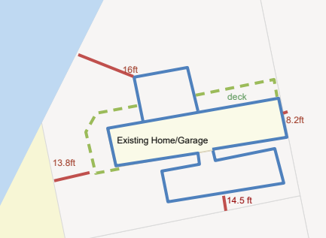
aao@riverdalemb.ca - Phone: 204-328-5300
A copy of the above proposal and supporting material may be inspected at the office location noted above during normal office hours (8:30 to 4:30) Monday to Friday. Copies may be made and extracts taken therefrom, upon request. Representations may be made either in person or preferably in writing, at the public hearing.

*Not to scale – for depictive purposes only


PLANNING DEPARTMENT

Public Hearing Frequently Asked Questions

Why did I receive a copy of this notice/why was this notice posted here?
Notifying owners of property located within 100 meters of the subject property is required as per The Planning Act. In addition to adjacent landowners being notified, depending on the type of actions being taken, notices may also be required to be placed in local newspapers, and sent to adjacent Municipalities/Planning Districts.

What is the main objective of the hearing?
The main objective of the hearing is to provide information to Council to assist in the decision-making process.

What is the structure of the hearing?
At the time and date of the hearing, the Head of Council will ask the applicant to speak about their application and answer any questions from Council. The Head of Council will then ask if anyone would like to speak for or against the application. When the hearing is concluded, there are no further chances for anyone to speak to Council on this matter.

I received a letter of the Hearing, am I required to attend?
Your attendance is welcomed, however, not required. We encourage the applicant to attend to present their application and answer any questions from Council.

Where can I get more information?
Contact Riverdale Municipality and request to speak to the Assistant Administrative Officer (AAO) to obtain more information on the application. A copy of the proposal and supporting material may be reviewed at the Municipal Office during regular office hours. Our office is located at 670-2nd Ave in Rivers, MB and is open Monday – Friday from 8:30am – 4:30pm. Our phone number is 204-328-5300

What if I have something to say, but cannot attend?
You may submit written comments to the AAO at least one week prior to hearing date. Please be advised that all correspondence received in conjunction with, or because of, an application that required Council approval becomes Public information, therefore personal information contained in the correspondence is release in public domain.
AAO Phone: 204-328-5300 AAO Email: aao@riverdalemb.ca

What happens after the Public Hearing for Conditional Use/Variation Orders?
After the hearing, Council will consider all appropriate materials and then do one of the following:
- Reject the application
- Issue a Conditional Use or a Variation Order, subject to such conditions as necessary or desirable to maintain the intent and purpose of the Zoning By-Law.
Once Council has made a decision, Council’s decision is final and binding. Council may revoke the Order made for any violation of the Order by an owner or applicant.

Any other questions may be directed to:

Laura Gill, Assistant Administrative Officer
670-2nd Ave | PO Box 520 Rivers, MB
204-328-5300 | aao@riverdalemb.ca

